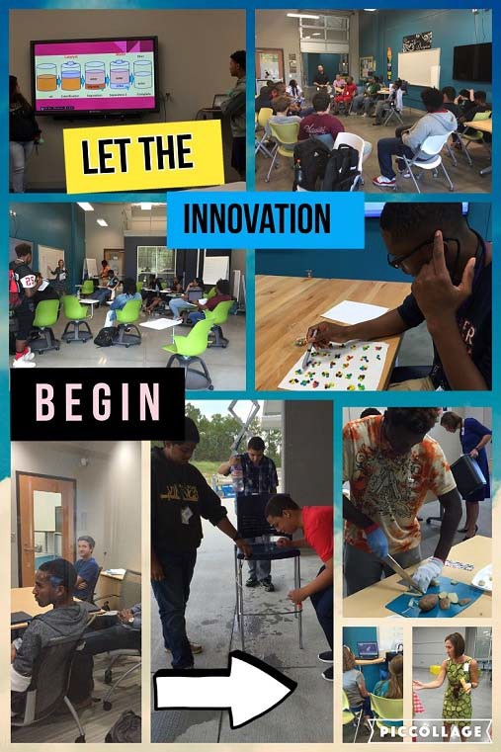

2019‐2020

R2i2 Course Guide

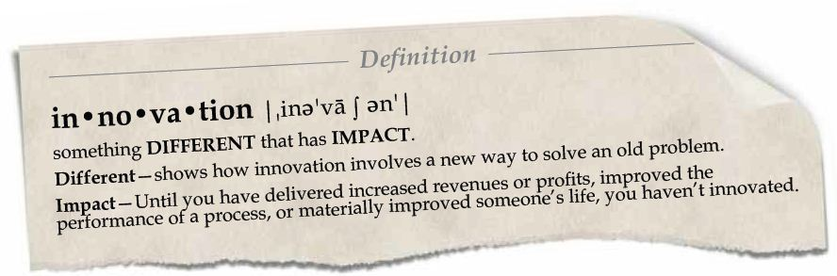

R2i2
Registration Guide

Richland Two Institute of Innovation (R2I2)
763 Fashion Drive Columbia, SC 29229
Mailing Address: 124 Risdon Way Columbia, SC 29223

R2i2
Mission Statement

As The Institute of Innovation, R2i2's mission is to foster individual student growth as an innovator within a safe environment by stimulating creativity, encouraging leadership, promoting teamwork, and building entrepreneurial skills while engaging the global community.

Richland School District 2 Comprehensive

Developmental School Counseling Mission

Richland School District Two outlines for each student, grades PK‐12, the personal, social, career, and educational knowledge and skills that support a rewarding and productive life in an ever‐changing world. The comprehensive guidance program framework of Richland School District Two provides standards and strategies for each school in the district to follow in developing and implementing a Comprehensive Developmental School Program.

Leadership Team
Kevin Alberse, Director
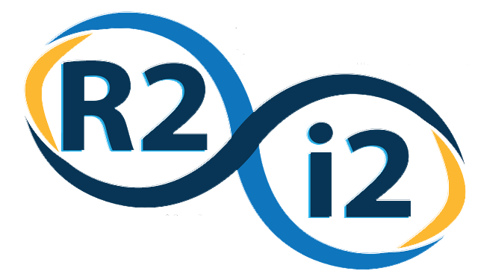
Jenniferr Cain, Assistant Principal
Maria Owens, Outreach Officer
Sandra Baker, Administrative Assistant
Faculty
Alvin Brown
Kirstin Bullington
Robin Jones
Nic Jones
Kelli Rembert
Marilyn Ross

R2i2 Course Offerings

Next Energy Engineering
Clean Energy Systems 1 638000CW or 638000HW: “Next Energy Engineering” 1 Honors or College Prep

This course exposes students to three sources of renewable energy: wind, solar and biofuels. Working with solar, thermal, chemical and mechanical sources of clean energy teaches students how to apply physics, geography, chemistry, biology, geometry, algebra and engineering fundamentals. Students learn the most efficient and appropriate use of energy production as they explore the relevant relationships

among work, power and energy. Students will engage in a wide variety of hands on projects and lab activities that both test their knowledge and illustrate the interrelationships between the various forms of clean energy. Credit: 1

Clean Energy Applications 2 638100CW or 638100HW- “Next Energy Engineering” 2 Honors or College Prep

This course builds on the foundation of Course 1 and introduces nuclear power, steam generation, fuel cells, geothermal power, water power, AC/DC power generation, heat transfer and the laws of thermodynamics. In addition, students now use chemical and thermal energy principles to create, store and use energy efficiently to power a variety of mechanical and electrical devices. Students will engage in a variety of hands-on design projects to demonstrate principles using advanced technology hardware and software. Credit: 1 Prerequisite: Successful completion of course 1 or permission of R2i2 instructor.

Clean Energy Strategies 3 638200HW (Honors, tentative): Students in this course utilize applicable skills from the foundational courses to tackle challenges associated with the implementation of clean energy technology. The hands-on projects encountered during this course will require students to address specific issues related to providing portable power in any situation, developing new energy storage systems, increasing the efficiency of the modern home, and designing more energy efficient buildings and homes. Credit: 1 Prerequisite: Successful completion of courses 1 & 2.

3D Printing & 3D Design w/CATIA
This course is offered in blocks. Blocks offer 2 credit hours.

Mechanical Design 1 617200CD , “3D Printing and 3D Design w/CATIA (v.5) I”
The 3D Printing and Design course at R2i2 will educate students on the use and application of CATIA v5: a multi-platform computer-aided design (CAD)/computer-aided manufacturing (CAM)/computer-aided engineering (CAE) software suite. Students will design parts and assemblies according to the specifications of each assignment and manufacture these parts using Additive Manufacturing. Students will prepare for professional certification in CATIA v5 in Mechanical Design 2 and receive more information on the pursuit of careers in this industry. Credits: 2

Mechanical Design 2 617300CD “3D Printing and 3D Design w/CATIA (v.5) II”

The 3D Printing and Design II course at R2i2 will advance student competency in the use and application of CATIA: a multi-platform computer-aided design (CAD)/computer-aided manufacturing (CAM)/computer-aided engineering (CAE) software suite. Students will design parts and assemblies according to the specifications of each assignment and manufacture these parts using Additive Manufacturing. Students will prepare for professional certification in CATIA and be introduced to the professional careers within these industries. Credits: 2

Architectural Design
This course is offered in blocks. Blocks offer 2 credit hours.

ARCHITECTURAL DESIGN 1 617000CD

The Architectural Design program prepares students to perform entry-level tasks under the supervision and guidance of architects and/or architectural engineers in the development and preparation of plans for residential and/or commercial buildings. Instruction is given in design technology and techniques, computer-aided design, zoning laws, building codes, cost planning, material requirements, styling, and client preferences. Upon successful completion of the architectural design program, students will be prepared for postsecondary education and entry-level architectural-related careers. This class will use the architectural standard software, Revit. Credits: 2

ARCHITECTURAL DESIGN 2 617100CD

This is a continuation and deeper study into the concepts learned in Architectural Design 1. Credits: 2, Prerequisite: Architectural Design 1

Global Business Logistics

Global Business Logistics 619901CW: Students will explore modern transportation logistics, highlighted by the use of drones. Students will be given an opportunity to learn about and fly drones as well as potentially obtain the Part 107 drone pilot’s license. Topics cover emerging and important areas such as product/service supply chains, security, sustainability, and supply chain vulnerability. Students will also be given an opportunity for fork lift certification. Credit: 1

Computer Forensics in the Global Supply Chain 609901CW:
Students will learn the importance of cyber forensics in the global supply chain and how to conduct investigations that include gathering evidence, using software to decode hidden files, and presenting findings. Organizations increasingly rely upon relationships with third-party vendors and partners. These relationships have become progressively more complex as companies engage in more cross-border relationships. A firm’s scrutiny of its supply chain technology is particularly important in the modern era of hacking and computer crimes. Failure to study adequately cyber-attacks can substantially increase an organization’s risk of significant financial losses, as well as exposure to legal investigations and reputational damage.

Credit: 1

Computer Programming and Coding

Computer Programming 1 “Apple Application Development” 505000CW:
Students will learn the Swift programming language and the Application Programming interface (API) to write their own Applications for use on iPhone and iPad. Students will work in teams and as individuals to develop apps using X-code. Credit: 1 (Satisfies Computer Science Graduation Requirement)

Culinary
Baking and Pastry: 572300CD
Baking and Pastry for secondary students is a course that provides students an opportunity to develop foundational skills needed for a seamless transition to a postsecondary program, workforce, or military. Students will develop advanced skills in safety and sanitation in addition to management and professionalism. Specialized content includes units on formulas and techniques, basic baking principles, specialized dietary baking, breads, desserts and pastries, and advanced techniques for specialty cakes, confections, piping, plate presentation, and flavor pairing. Concepts are aligned with competencies from the American Culinary Federation (ACF) Education foundation assessment, ACF Retail Commercial Baking Certification. Integration of the strategies from the Family and Consumer Sciences student organization, Family, Career and Community Leaders of America (FCCLA), provides leadership and entrepreneurship development in addition to an opportunity to compete and demonstrate technical skill attainment. Credits: 2

Business
Virtual Enterprise “Virtual & Micro-Business 1 and 2” 515000CW & 5151000CW:
This course is an in-school, live, business simulation that offers students a competitive edge through project-based, collaborative learning, and the development of 21st-century skills in entrepreneurship, global business, problem solving, communication, personal finance, and technology. This multidimensional, experiential learning model develops high school students into independent-thinking business professionals. Credits: 2 THIS IS A YEAR-LONG SKINNY

Virtual Enterprise “Virtual & Micro-Business 3 and 4” 5152000CW & 5153000CW:
This section of the course will be a continuation of and expansion on the principles of starting and running a successful business. Credits: 2, Prerequisite VEI 1 & 2, THIS IS A YEAR-LONG SKINNY

Social Media & Business “Marketing and Social Media”: 503400CW: Designed specifically for students who are interested in a marketing related career. Students will develop those skills required for success as a marketing manager by examining real‐world marketing problems. This course is research‐intensive, group‐oriented, and comprehensive. Explores implications, opportunities and challenges for business and communications professionals using social media and contemporary advertising for organizations. Students will participate in creation of a vast array of social media sites, resources, applications and tools, as well as evaluate the impact, effectiveness and design of various elements of advertising strategy and campaigns. Credit: 1

Dual Credit Course Offerings

R2I2 continues to explore options for Dual Credit course offerings. As soon as information is verified and available, it will be sent directly to the School Counselors.

Virtual English and Math Offerings @ R2i2

R2I2 continues to explore options for virtual course offerings. As soon as information is verified and available, it will be sent directly to the School Counselors.

